**Google Drive API with HydroShare Python – Part II**

Adapted from: # <https://levelup.gitconnected.com/google-drive-api-with-python-part-ii-connect-to-google-drive-and-search-for-file-7138422e0563>

1. Log in in HydroShare JupyterHub and access the Python terminal. Install the google-api-python-client and oauth2client libraries.

pip install google-api-python-client

pip install oauth2client

1. Create a folder in the project directory called “credentials” to store your “client_secret.json” which you downloaded from the Part I document. For any different project the credentials subfolder should be copied.
2. The structure of your project folder should be like this to work:

project_folder  
|  
|__credentials  
| |  
| |__client_secret.json  
|  
|__connect_to_google_drive.py

Let’s write the code that needs to go into “connect_to_google_drive.py”. In the notebook directory, click on New, Text File, conpy and paste the code below, and rename it to connect_to_google_drive.py. Click on File, Save. (You can close now this tab and see that a python file is in your project folder.

from apiclient import discovery

from httplib2 import Http

from oauth2client import client, file, tools

# define path variables

credentials_file_path = './credentials/credentials.json'

clientsecret_file_path = './credentials/client_secret.json'

# define API scope

SCOPE = 'https://www.googleapis.com/auth/drive'

# define store

store = file.Storage(credentials_file_path)

credentials = store.get()

# get access token

if not credentials or credentials.invalid:

flow = client.flow_from_clientsecrets(clientsecret_file_path, SCOPE)

credentials = tools.run_flow(flow, store)

1. Your access token will be stored in credentials/credentials.json upon the browser authentication, which I will go through after this.
2. In terminal navigate to your project folder and pass the execute the python file

jovyan@c6d25d66a3d2:~/notebooks/git-repos/nsf_dsaw_application_1$ python connect_to_google_drive.py --noauth_local_webserver.

1. A similar link will show in the terminal:

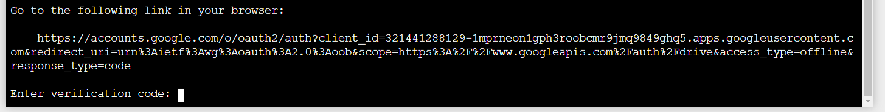

1. Select the 3lines web address (with your mouse and then right click), paste it in a new tab, select the gmail account and the page will show a code, which needs to be pasted to the terminal (mouse right click, paste)
2. A new file called “credentials.json” is created in the “credentials” folder. This concludes the setup of the Drive API in HS.